**Data Structures and Algorithms**

**Lab Journal - Lab 2**

Name: Saad Ahmad

Enrollment #: 01-134222-130

Class/Section: BS -CS-3A

**Objective**

This lab is intended to introduce students to Stacks and their applications. The students will implement the Stack and employ it in solving the given problems.

**Task 1 :**

Give the answers to the following:

Show the contents of stack (at each step) once the following sequence of statements is executed. Write the code of executing these statements exactly like as given below:

Stack S;

|  |  |  |  |  |  |  |  |  |  |  |  |  |  |  |  |  |  |  |  |  |  |  |  |  |  |  |  |
| --- | --- | --- | --- | --- | --- | --- | --- | --- | --- | --- | --- | --- | --- | --- | --- | --- | --- | --- | --- | --- | --- | --- | --- | --- | --- | --- | --- |
| 1. | Show the contents of stack (at each step) once the following sequence of statements is executed.  Stack S;   |  |  | | --- | --- | | 1. S.Push(‘F’); | F | | 1. S.Push(‘A’); | FA | | 1. S.Push(‘T’); | FAT | | 1. S.Pop(); | FA | | 1. S.Pop(); | F | | 1. S.Push(‘I’); | FI | | 1. S.Push(‘M’); | FIM | | 1. S.Pop(); | FI | | 1. S.Push(‘A’); | FIA | | 1. S.Push(‘O’); | FIAO | | 1. S.Push(‘K’); | FIAOK | | 1. S.Pop(); | FIAO | | 1. S.Pop(); | FIA | |

#include <iostream>

#include <stack>

using namespace std;

int main() {

stack<char> s;

s.push('F');

s.push('A');

s.push('T');

s.pop();

s.pop();

s.push('I');

s.push('M');

s.pop();

s.push('A');

s.push('O');

s.push('K');

s.pop();

s.pop();

while (!s.empty()) {

cout << s.top();

s.pop();

}

}

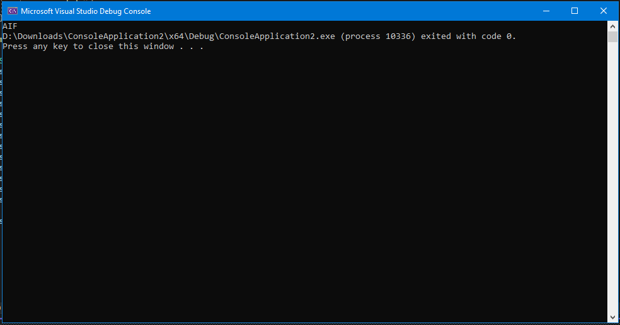

#include <iostream>

using namespace std;

const int maxsize = 5;

class Stack {

int top;

char arr[maxsize];

public:

Stack() {

top = -1;

}

void push(char temp) {

if (top == (maxsize - 1)) {

cout << "Stack Overflow" << endl;

}

else {

arr[++top] = temp;

}

}

void pop() {

top--;

}

bool empty() {

if (top == -1) {

return true;

}

else {

return false;

}

}

void display() {

while (!this->empty()) {

cout << arr[top];

this->pop();

}

}

};

int main()

{

Stack s;

s.push('F');

s.push('A');

s.push('T');

s.pop();

s.pop();

s.push('I');

s.push('M');

s.pop();

s.push('A');

s.push('O');

s.push('K');

s.pop();

s.pop();

s.display();

}

